**ASSIGNMENT JENKINS PROJECT**

**1.**click on new project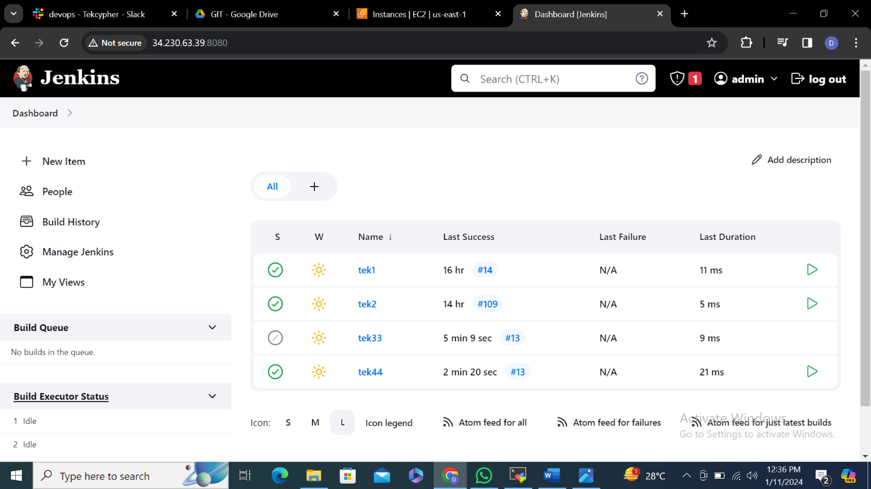

**2.**Enter project name tek44 and select free style project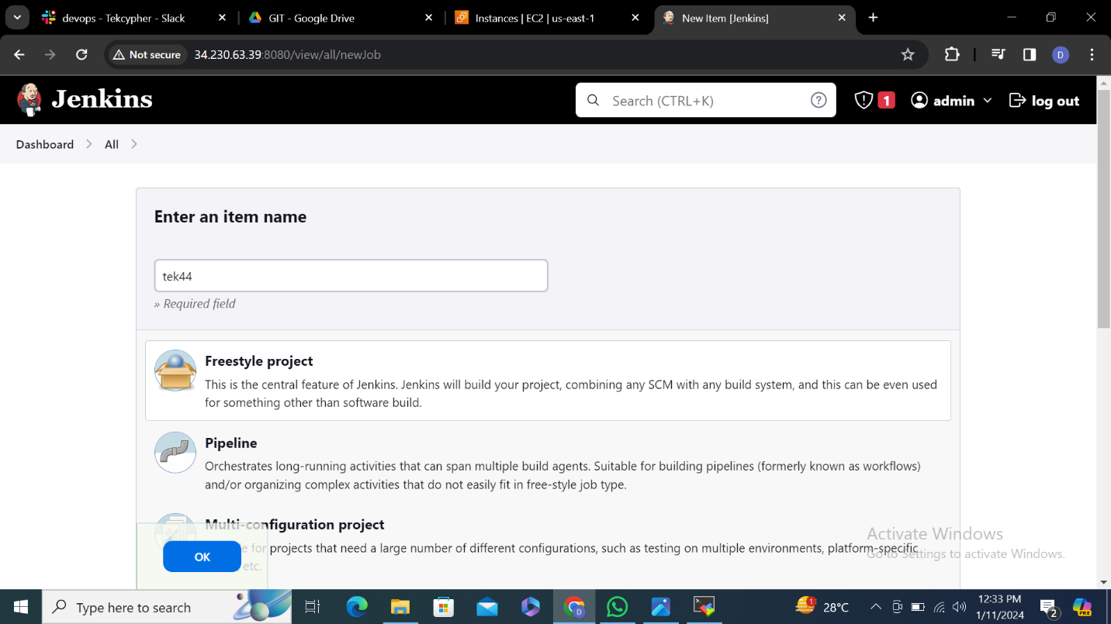

**3.DISCARD OLD BUILDS** enter 10 previous builds will be deleted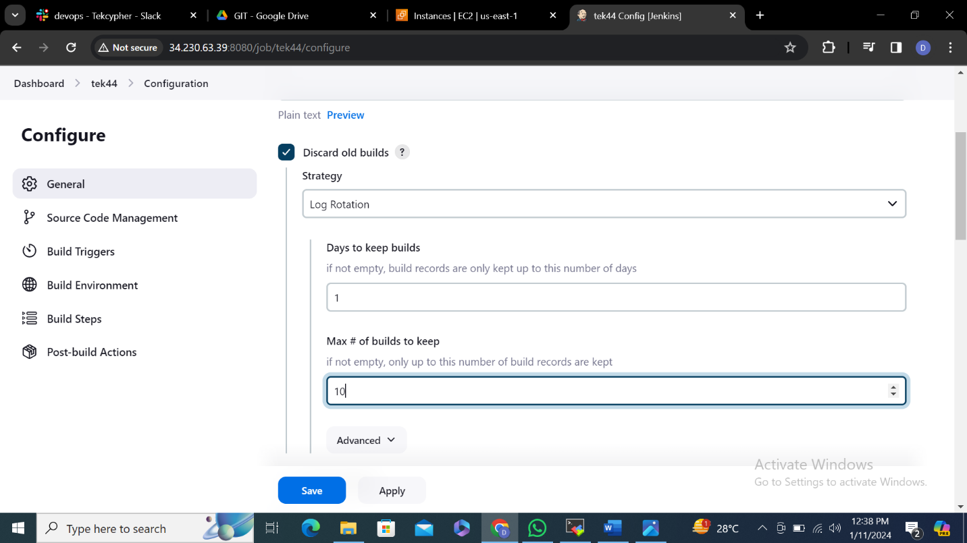

**4.**

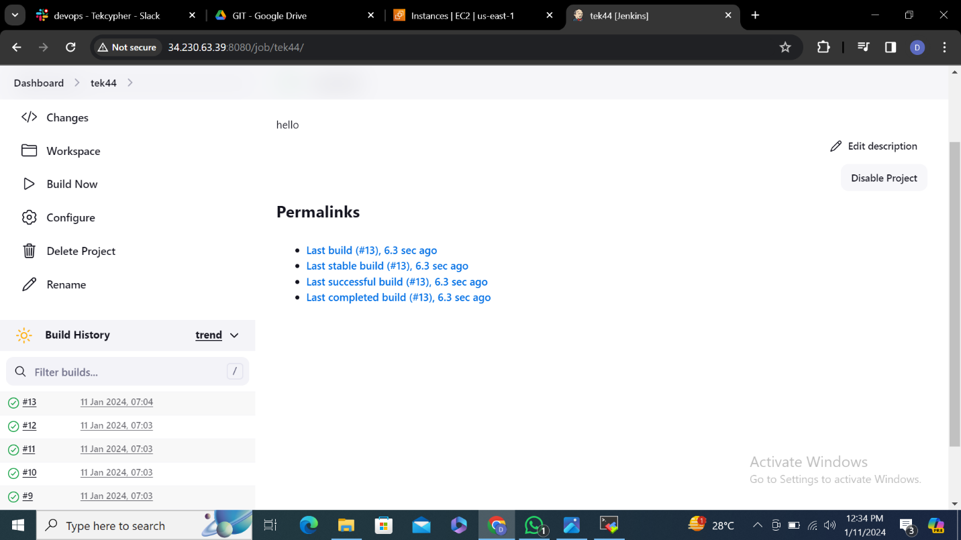

**5.This project is parameterised select Boolean parameter**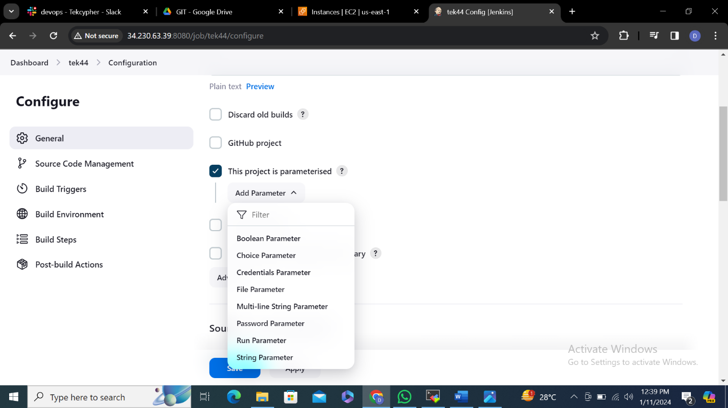

**6.**boolean means true or false

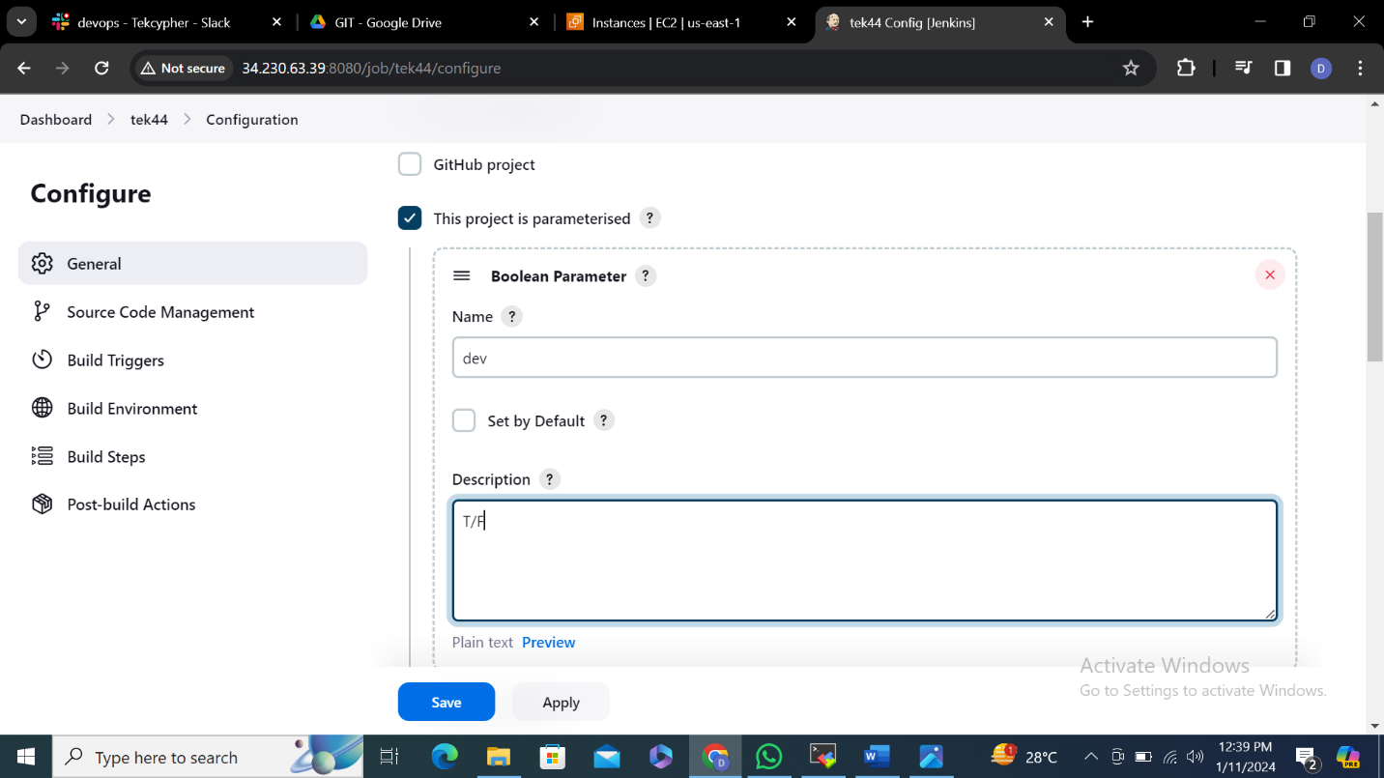

**7.click on build**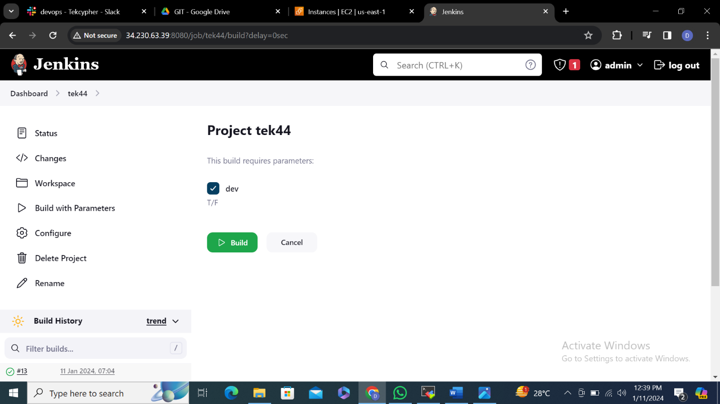

**8.**

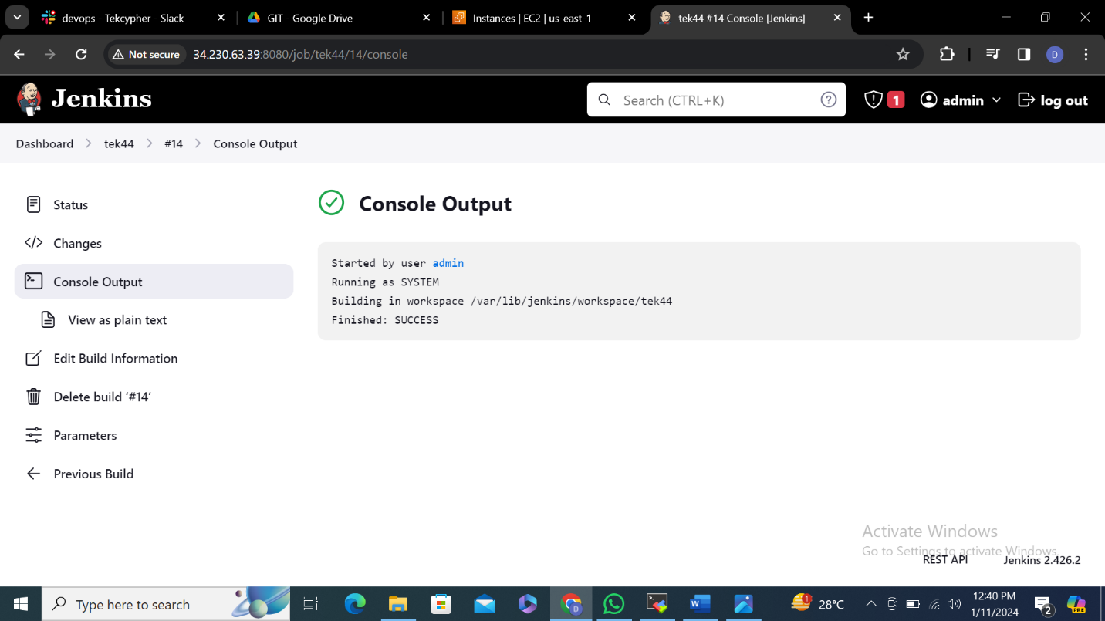

**9.CHOICE PARAMETER**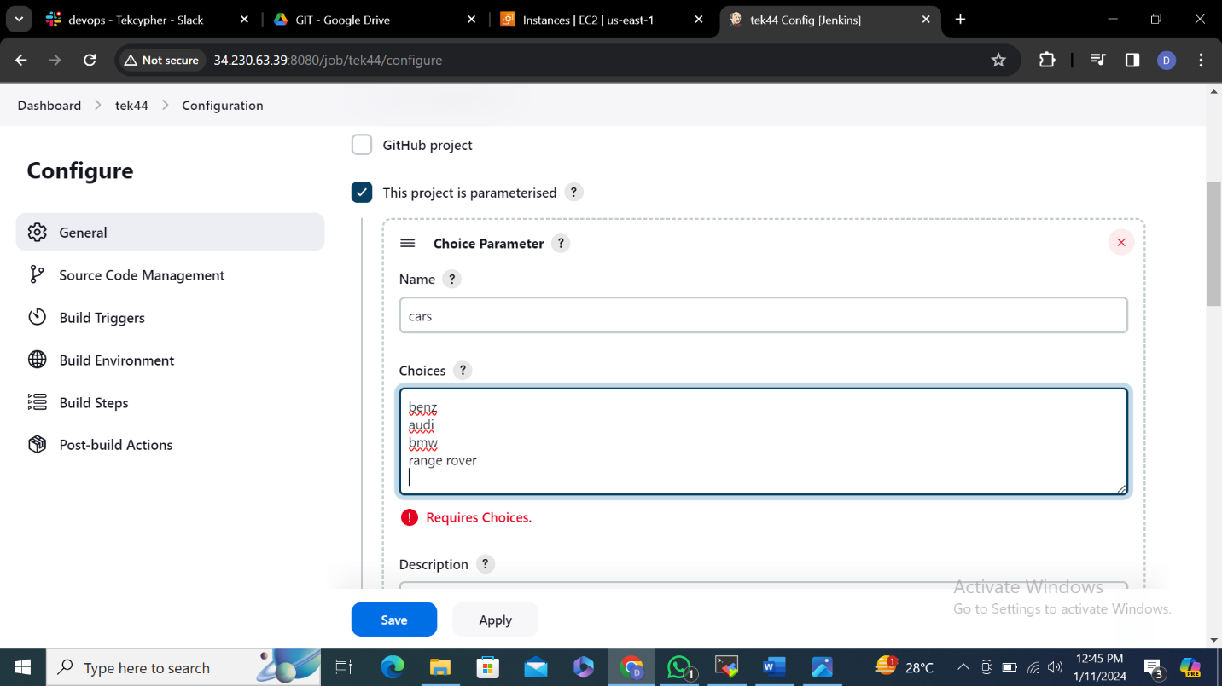

**10.select any option**

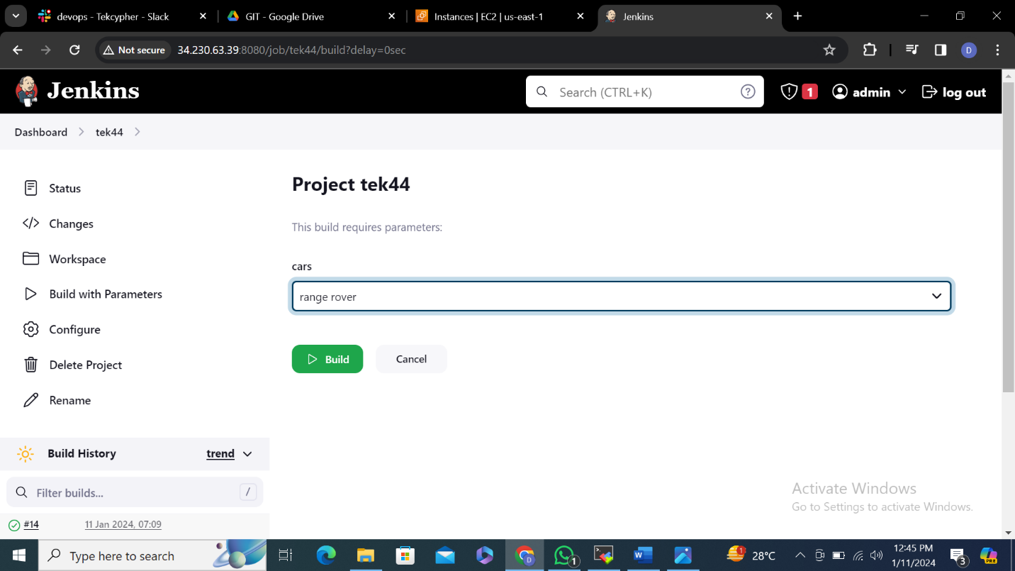

**11.**

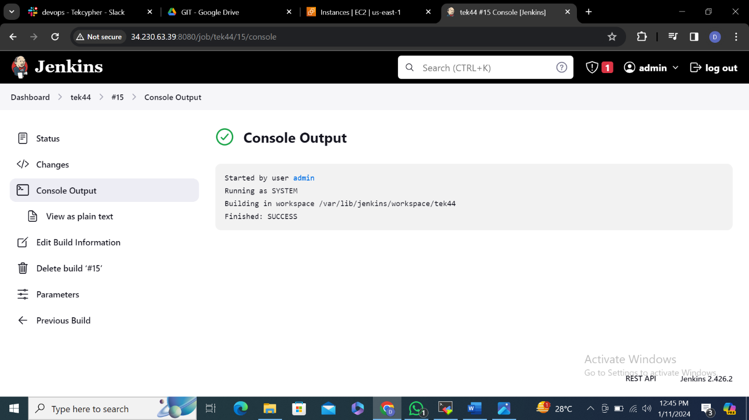

**12. PASSWORD PARAMETER select username and password**

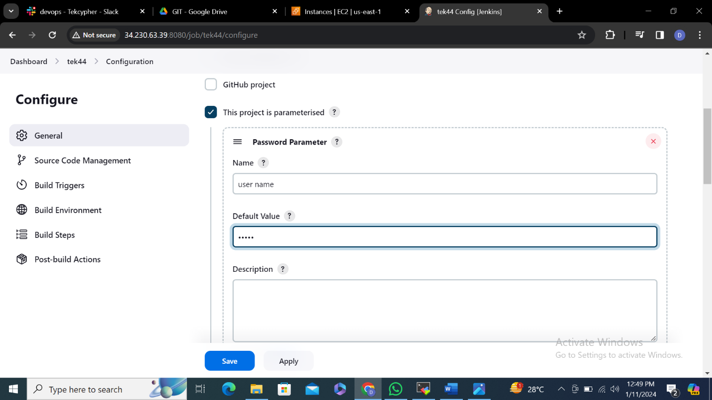

**13.click on build**

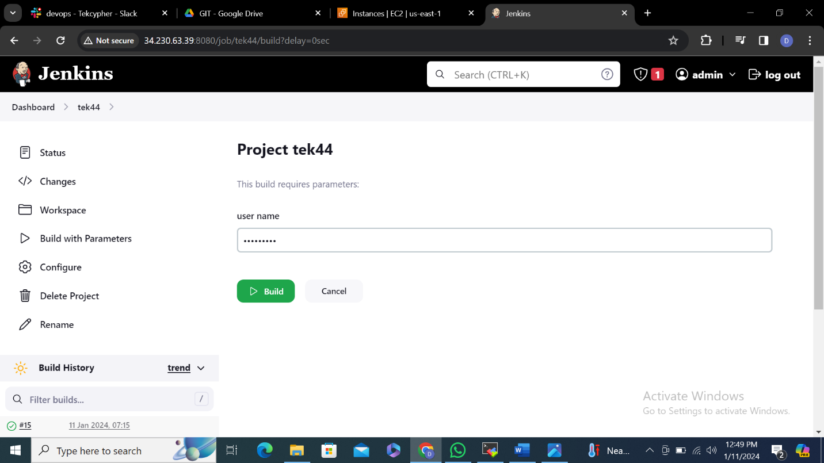

**14.**

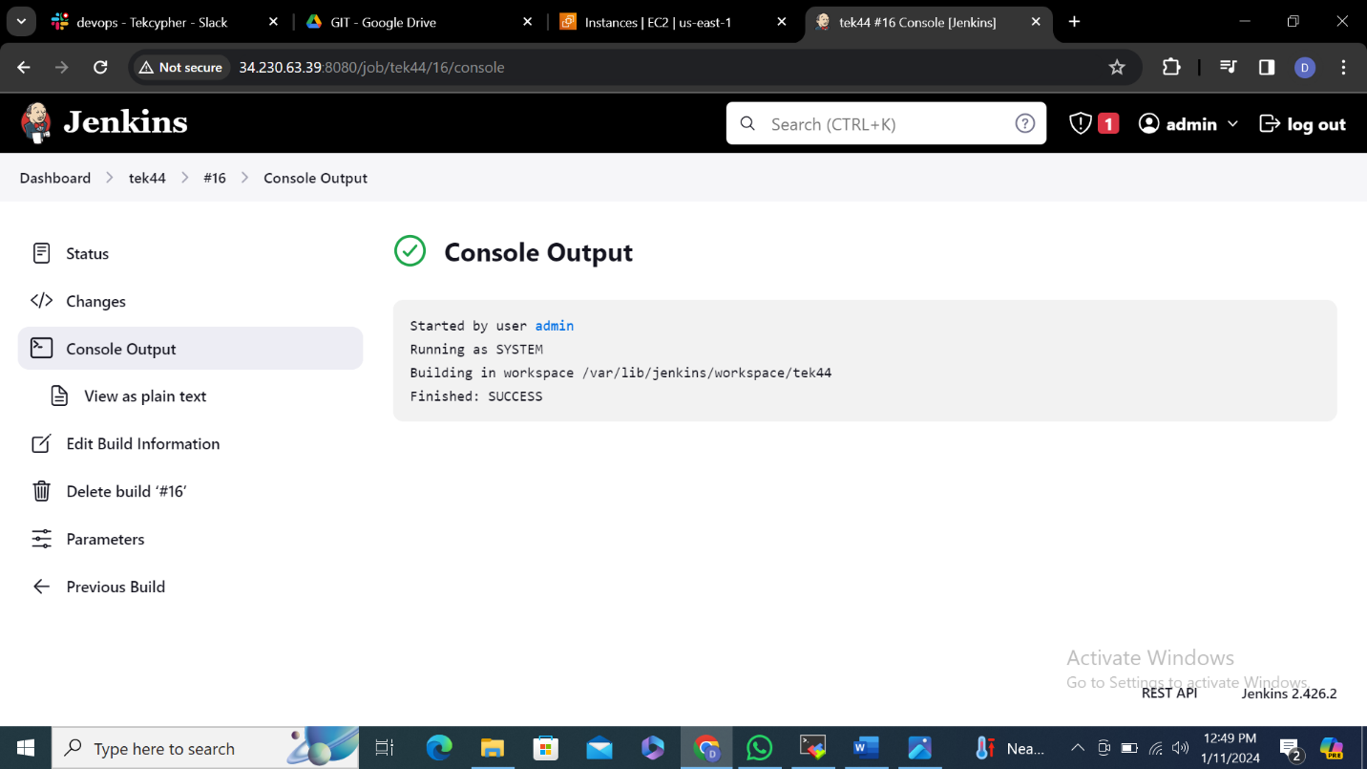

**15.THROTTLE BUILDS for every 10 sec 1 build will generate**

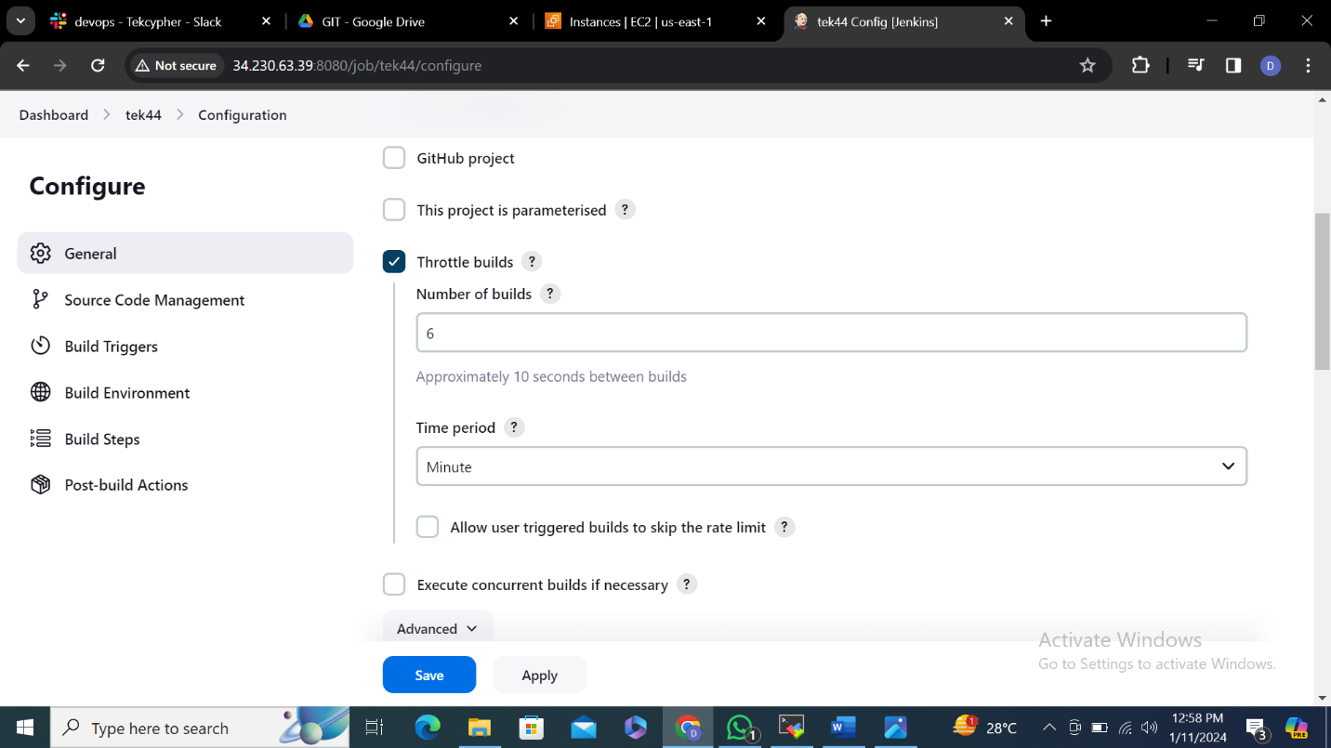

**16.**

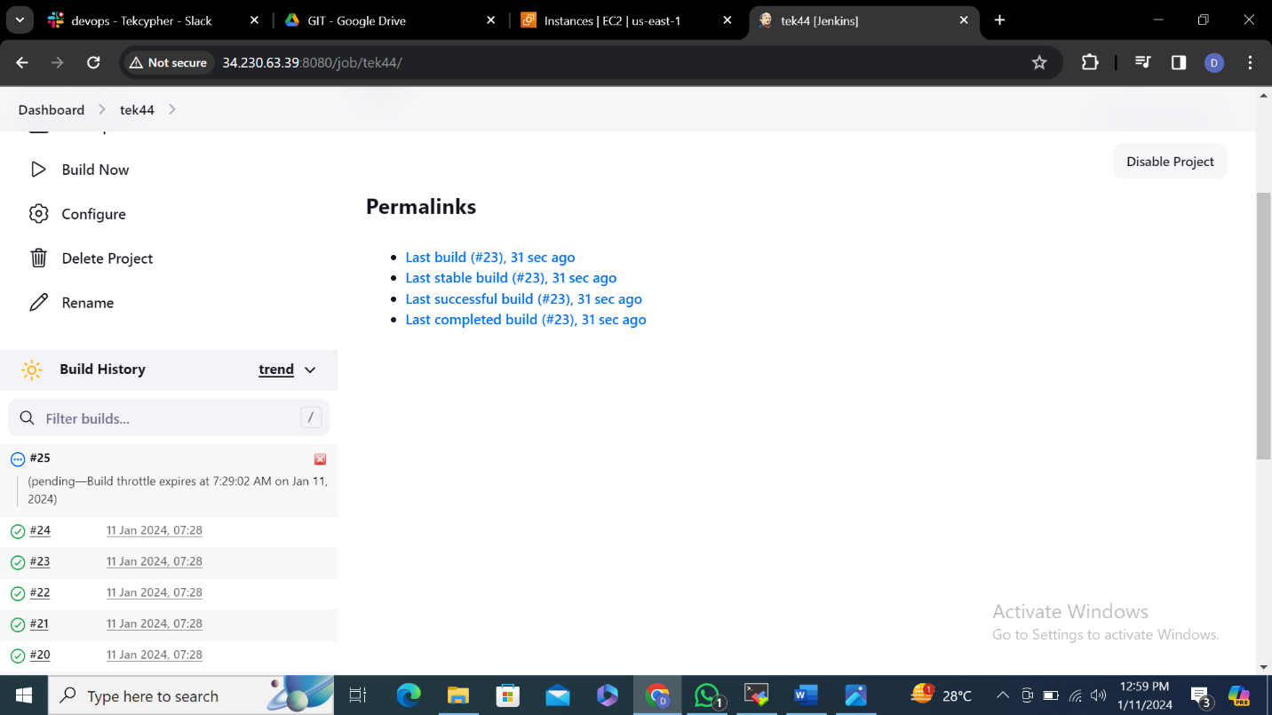

**17.**

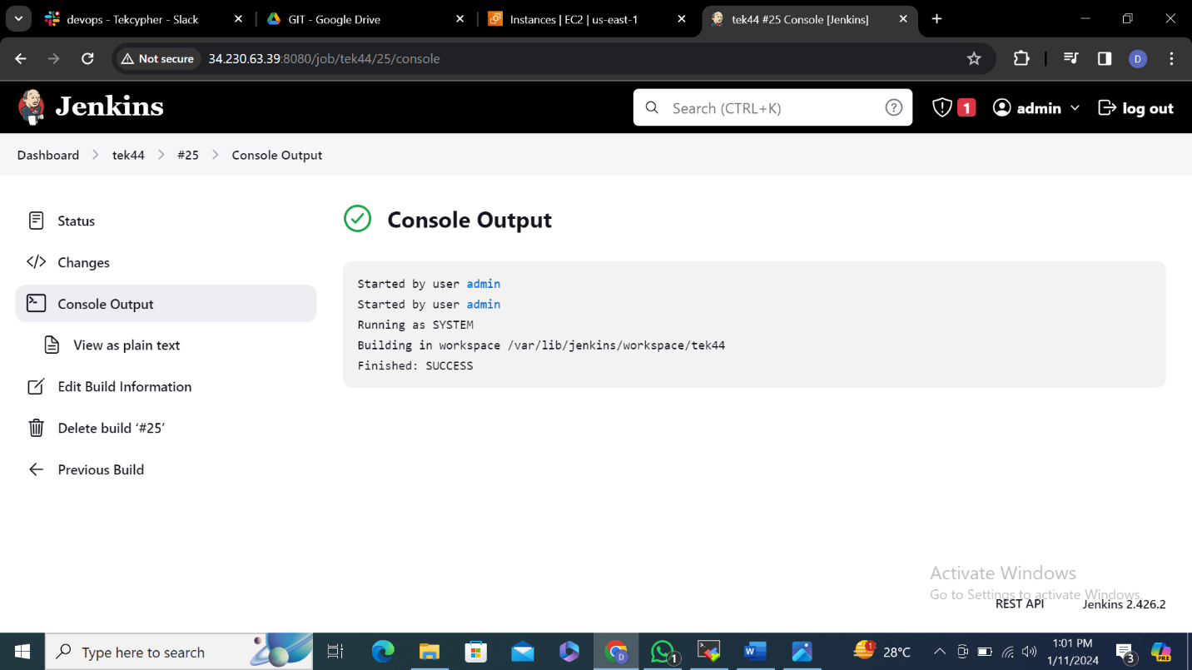

**18.EXECUTE CONCURRENT BUILDS IF NECESSARY**

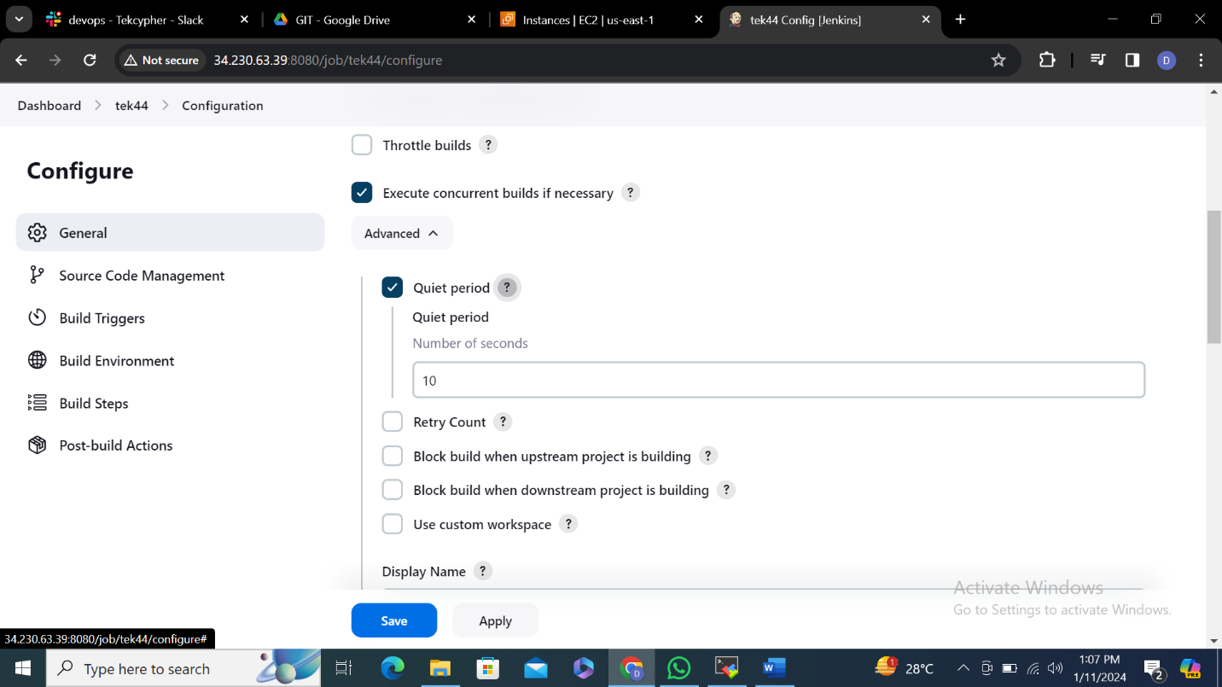

**19.**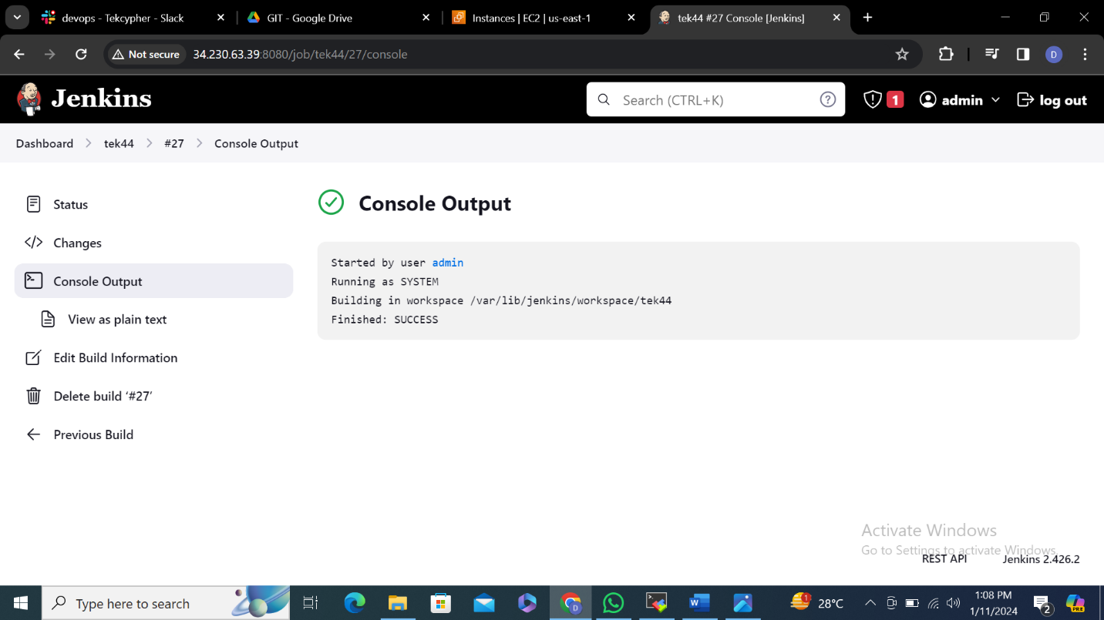

**20.BUILD TRIGGER** this url works when you shutdown your pc you need to have token and public ip address

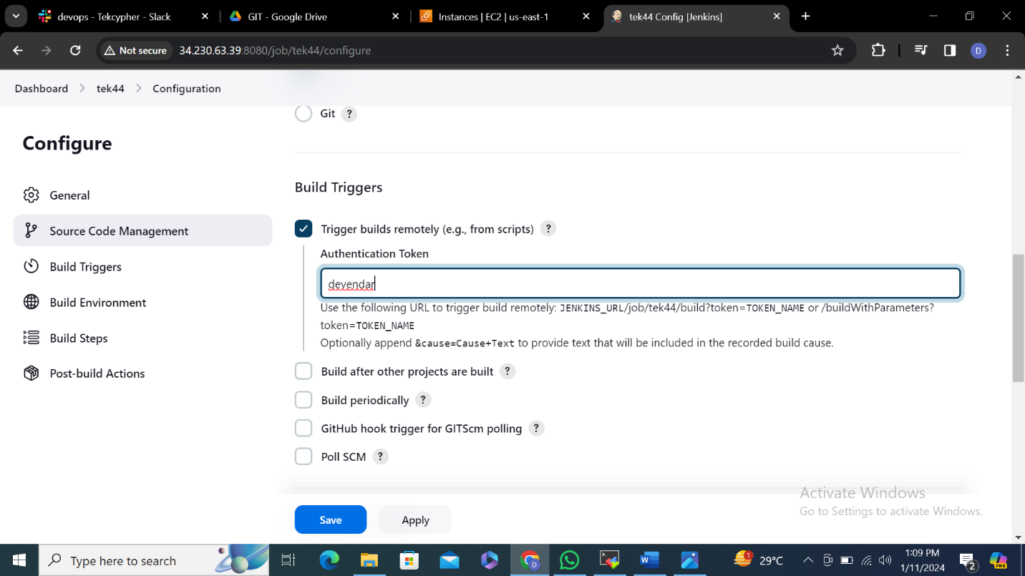

**21.**

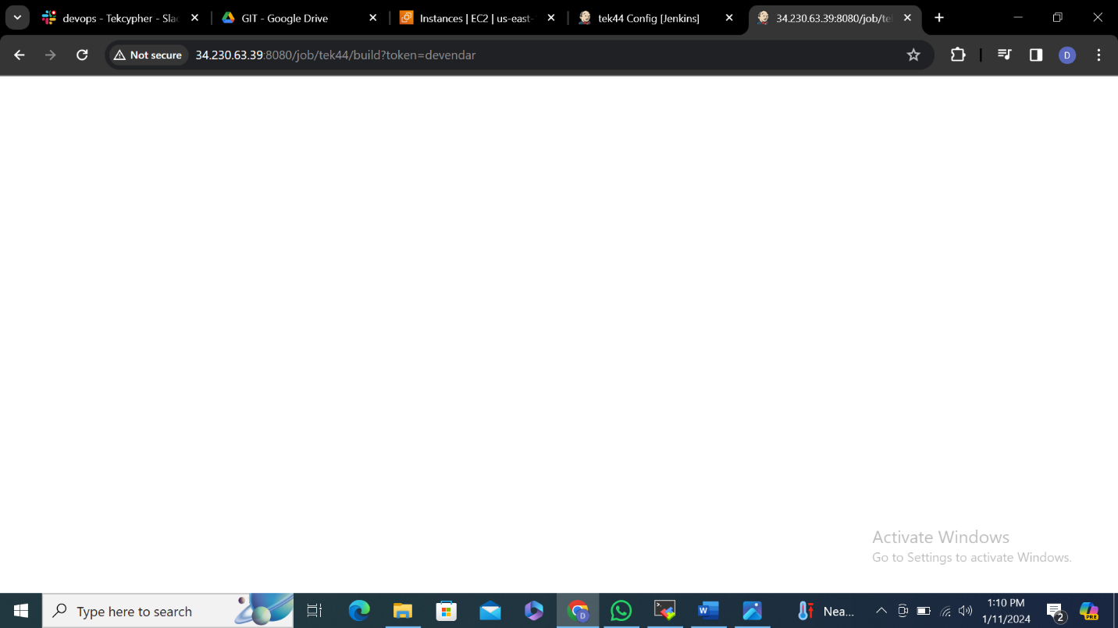

**22.**

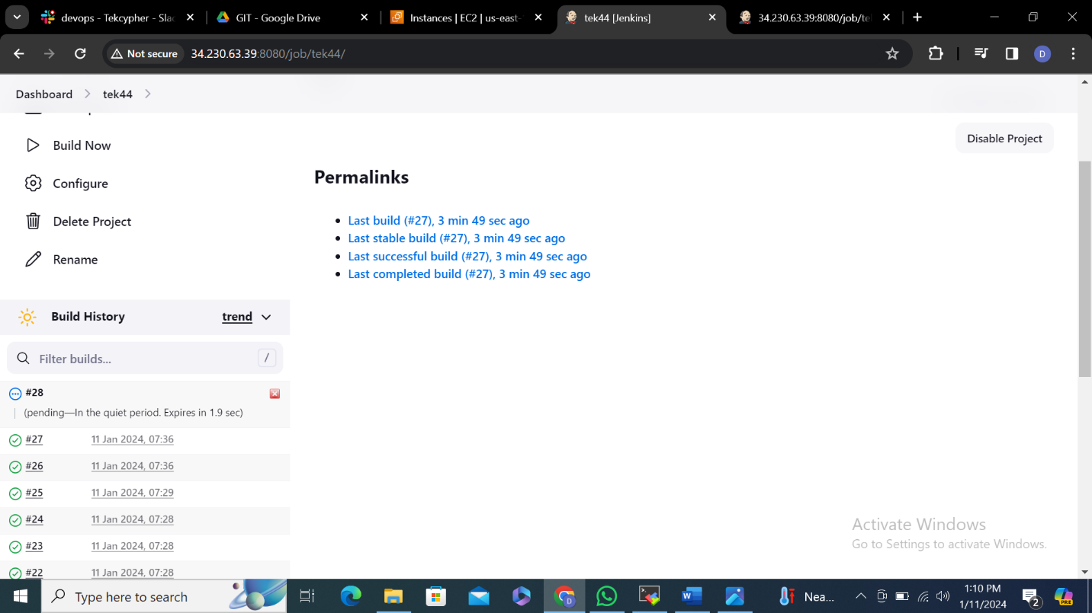

**23.with the help of public ip it is generated**

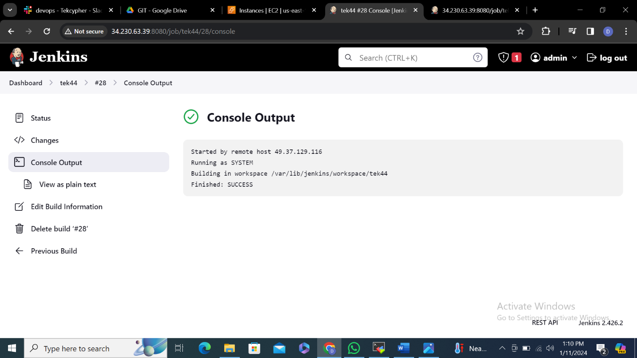

**24.BUILD AFTER OTHER PROJECTS ARE BUILT**

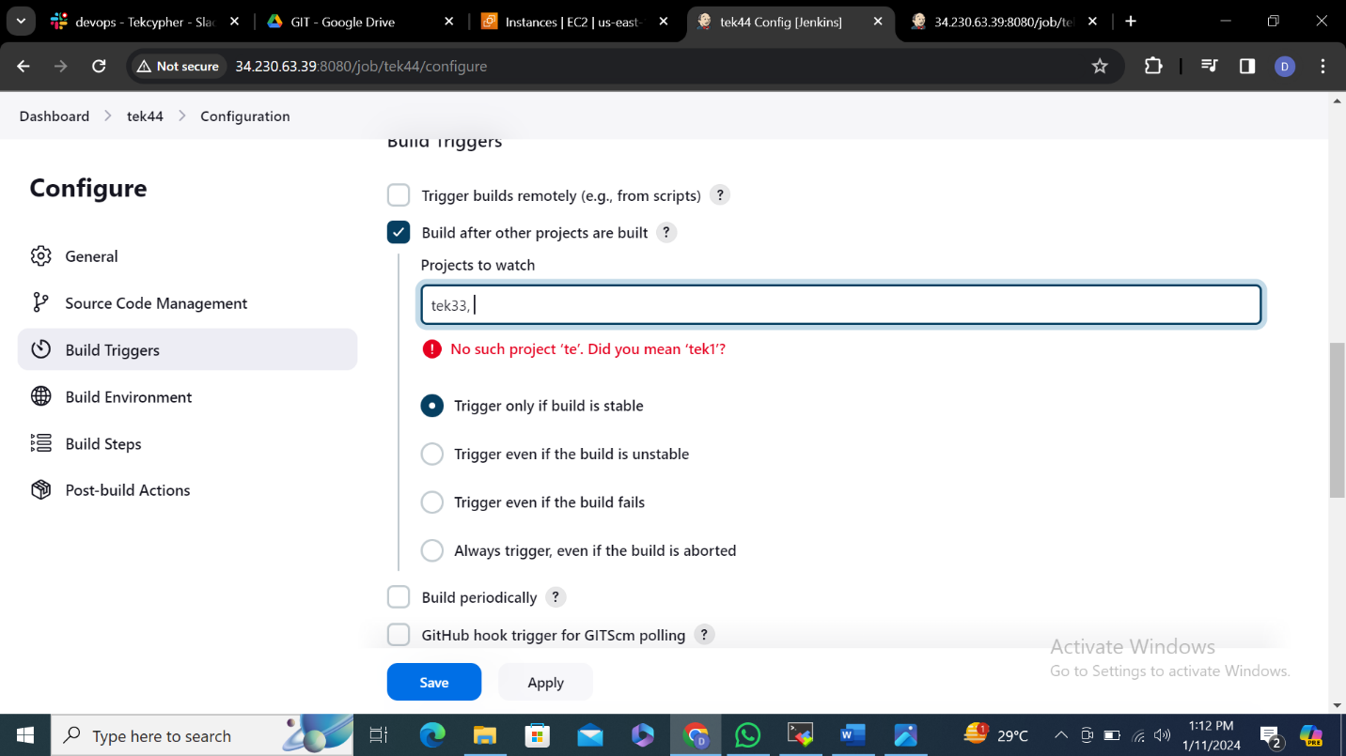

**25.**after one project is build another project is build

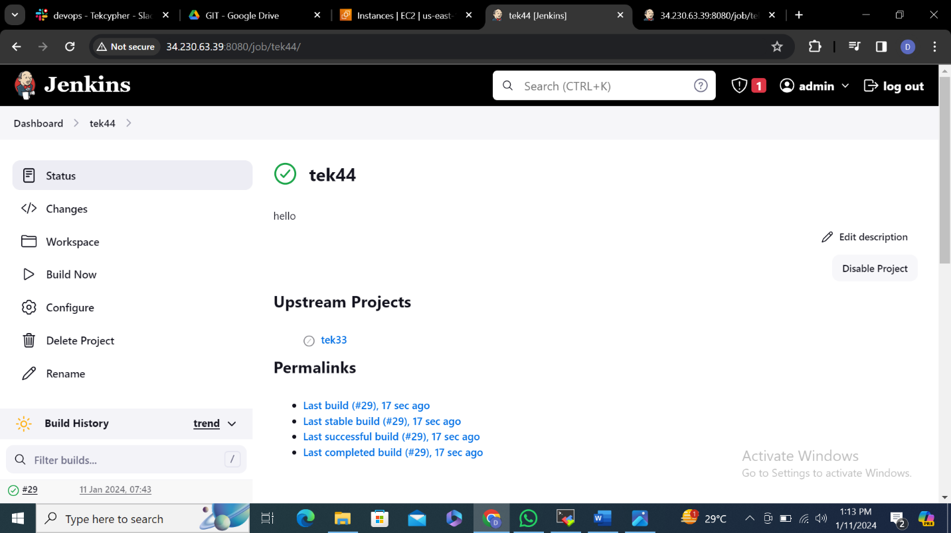

**26.**

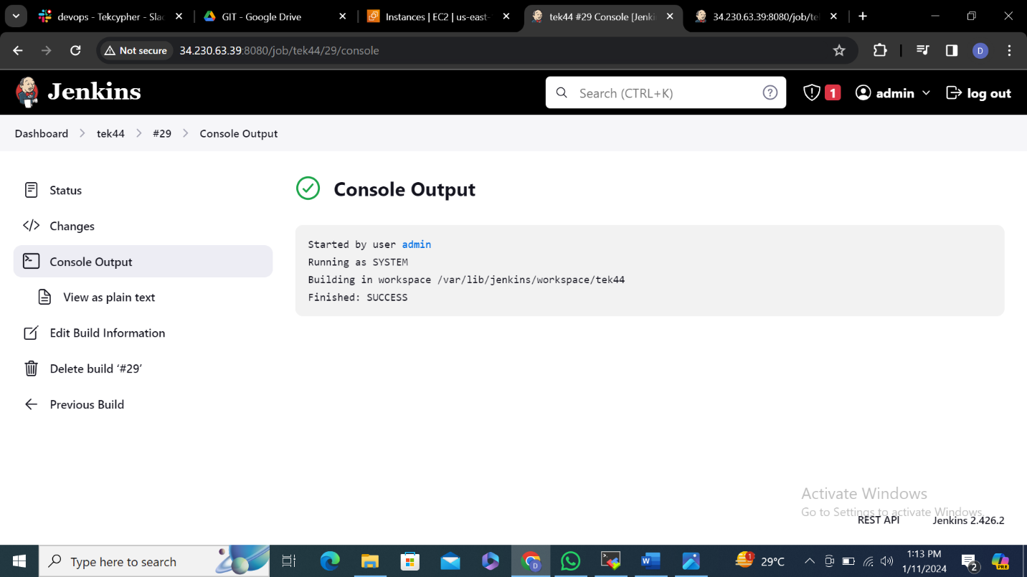

**27.BUILD PERIODICALLY** we need to give time so that at particular time build will be generated

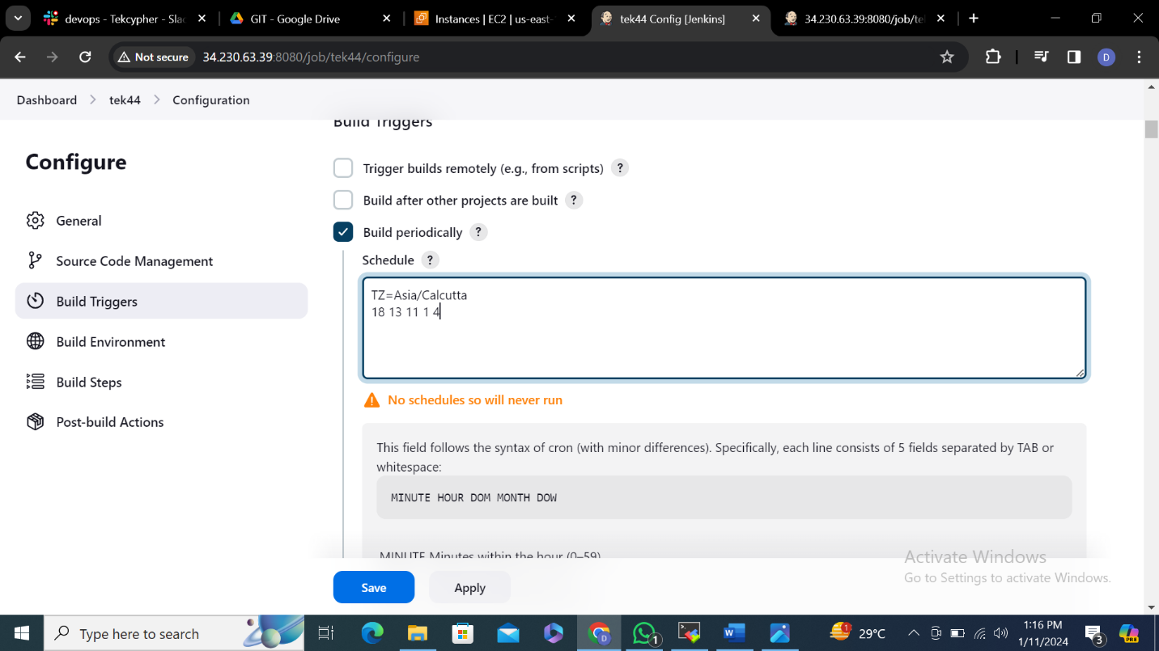

**28.**

